IET DEPARTMENT



Data Structure and Algorithm
Lab Manual
Lab 5: Doubly Linked
Objective
- Doubly Link List
- Operation in doubly link list
- Circular Link List Introduction

- Introduction
A linked list is a data structure that can store an indefinite amount of items. These items are connected using pointers in a sequential manner.
Examples
- A simple real life example is a Train, here each coach is connected to its previous and next coach (Except first and last). In terms of programming consider coach body as node value and connectors as links to previous and next nodes.
- Consider the history section of web browsers, where it creates a linked list of web-pages visited, so that when you check history (traversal of a list) or press back button, the previous node's data is fetched.
Types of Link list are:
i) Doubly Link List ii) Circular Link List

- Activity Time boxing
Task No. | Activity Name | Activity time | Total Time
1 | Introduction of doubly List | 10 mins
2 | Insertion, deletion in doubly link list | 10 mins
3, | Introduction of circular List | 10 mins
4 | Lab Exercise. Evaluation | 140 mins. | 170 mins

- Lab Manual Lecture [Expected time = 40 minutes]
Doubly Link List
Doubly Linked List is a variation of Linked list in which navigation is possible in both ways, either forward and backward easily as compared to Single Linked List. Following are the important terms to understand the concept of doubly linked list.
- Link − Each link of a linked list can store a data called an element.
- Next − Each link of a linked list contains a link to the next link called Next.
- Prev − Each link of a linked list contains a link to the previous link called Prev.
- LinkedList − A Linked List contains the connection link to the first link called First and to the last link called Last.
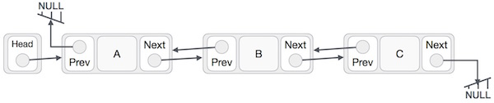
Implementation of Link List
As per the above illustration, following are the important points to be considered.
- Doubly Linked List contains a link element called first and last.
- Each link carries a data field(s) and two link fields called next and prev.
- Each link is linked with its next link using its next link.
- Each link is linked with its previous link using its previous link.
- The last link carries a link as null to mark the end of the list.

C++ Code
Class Linked_List
class node
{
node *prev;
int data;
node *next;
}
The prev part of the first node and the next part of the last node will always contain null indicating end in each direction.
In a singly linked list, we could traverse only in one direction, because each node contains address of the next node and it doesn't have any record of its previous nodes. However, doubly linked list overcome this limitation of singly linked list. Due to the fact that, each node of the list contains the address of its previous node, we can find all the details about the previous node as well by using the previous address stored inside the previous part of each node.

Advantages over singly linked list
- A DLL can be traversed in both forward and backward direction.
- The delete operation in DLL is more efficient if pointer to the node to be deleted is given.
- We can quickly insert a new node before a given node.
- In singly linked list, to delete a node, pointer to the previous node is needed. To get this previous node, sometimes the list is traversed. In DLL, we can get the previous node using previous pointer.
Disadvantages over singly linked list
- Every node of DLL Require extra space for a previous pointer. It is possible to implement DLL with single pointer though.
- All operations require an extra pointer previous to be maintained. For example, in insertion, we need to modify previous pointers together with next pointers.
Operations:
SN | Operation | Description
1 | Insertion at beginning | Adding the node into the linked list at beginning.
2 | Insertion at end | Adding the node into the linked list to the end.
3 | Insertion after specified node | Adding the node into the linked list after the specified node.
4 | Deletion at beginning | Removing the node from beginning of the list
5 | Deletion at the end | Removing the node from end of the list.
6 | Deletion of the node having given data | Removing the node which is present just after the node containing the given data.
7 | Searching | Comparing each node data with the item to be searched and return the location of the item in the list if the item found else return null.
8 | Traversing | Visiting each node of the list at least once in order to perform some specific operation like searching, sorting, display, etc.
Sample Program
Insertion at beginning
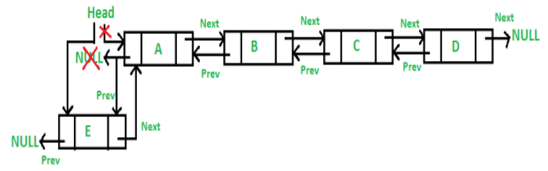
/* Make next of new node as head and previous as NULL */
new_Node.next = head;
new_Node.prev = null;

/* change prev of head node to new node */
if (head != null)
head.prev = new_Node;

/* move the head to point to the new node */
head = new_Node;

Insertion after given node
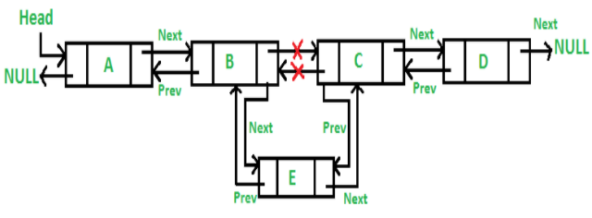
/* Make next of new node as next of prev_node */
new_node.next = prev_Node.next;

/* Make the next of prev_node as new_node */
prev_Node.next = new_node;

/*Make prev_node as previous of new_node */
new_node.prev = prev_Node;

/* Change previous of new_node's next node */
if (new_node.next != null)
new_node.next.prev = new_node;
Algorithms:
Inserting At Beginning of the list
We can use the following steps to insert a new node at beginning of the double linked list...
Step 1 - Create a newNode with given value and newNode → previous as NULL.
Step 2 - Check whether list is Empty (head == NULL)
Step 3 - If it is Empty then, assign NULL to newNode → next and newNode to head.
Step 4 - If it is not Empty then, assign head to newNode → next and newNode to head.
Inserting At End of the list
We can use the following steps to insert a new node at end of the double linked list...
Step 1 - Create a newNode with given value and newNode → next as NULL.
Step 2 - Check whether list is Empty (head == NULL)
Step 3 - If it is Empty, then assign NULL to newNode → previous and newNode to head.
Step 4 - If it is not Empty, then, define a node pointer temp and initialize with head.
Step 5 - Keep moving the temp to its next node until it reaches to the last node in the list (until temp → next is equal to NULL).
Step 6 - Assign newNode to temp → next and temp to newNode → previous.
Inserting At Specific location in the list (After a Node)
We can use the following steps to insert a new node after a node in the double linked list...
Step 1 - Create a newNode with given value.
Step 2 - Check whether list is Empty (head == NULL)
Step 3 - If it is Empty then, assign NULL to both newNode → previous & newNode → next and set newNode to head.
Step 4 - If it is not Empty then, define two node pointers temp1 & temp2 and initialize temp1 with head.
Step 5 - Keep moving the temp1 to its next node until it reaches to the node after which we want to insert the newNode (until temp1 → data is equal to location, here location is the node value after which we want to insert the newNode).
Step 6 - Every time check whether temp1 is reached to the last node. If it is reached to the last node then display 'Given node is not found in the list!!! Insertion not possible!!!' and terminate the function. Otherwise move the temp1 to next node.
Step 7 - Assign temp1 → next to temp2, newNode to temp1 → next, temp1 to newNode → previous, temp2 to newNode → next and newNode to temp2 → previous.
Deletion Algorithms
In a double linked list, the deletion operation can be performed in three ways as follows...
Deleting from Beginning of the list
We can use the following steps to delete a node from beginning of the double linked list...
Step 1 - Check whether list is Empty (head == NULL)
Step 2 - If it is Empty then, display 'List is Empty!!! Deletion is not possible' and terminate the function.
Step 3 - If it is not Empty then, define a Node pointer 'temp' and initialize with head.
Step 4 - Check whether list is having only one node (temp → previous is equal to temp → next)
Step 5 - If it is TRUE, then set head to NULL and delete temp (Setting Empty list conditions)
Step 6 - If it is FALSE, then assign temp → next to head, NULL to head → previous and delete temp.
Deleting from End of the list
We can use the following steps to delete a node from end of the double linked list...
Step 1 - Check whether list is Empty (head == NULL)
Step 2 - If it is Empty, then display 'List is Empty!!! Deletion is not possible' and terminate the function.
Step 3 - If it is not Empty then, define a Node pointer 'temp' and initialize with head.
Step 4 - Check whether list has only one Node (temp → previous and temp → next both are NULL)
Step 5 - If it is TRUE, then assign NULL to head and delete temp. And terminate from the function. (Setting Empty list condition)
Step 6 - If it is FALSE, then keep moving temp until it reaches to the last node in the list. (until temp → next is equal to NULL)
Step 7 - Assign NULL to temp → previous → next and delete temp.
Deleting a Specific Node from the list
We can use the following steps to delete a specific node from the double linked list...
Step 1 - Check whether list is Empty (head == NULL)
Step 2 - If it is Empty then, display 'List is Empty!!! Deletion is not possible' and terminate the function.
Step 3 - If it is not Empty, then define a Node pointer 'temp' and initialize with head.
Step 4 - Keep moving the temp until it reaches to the exact node to be deleted or to the last node.
Step 5 - If it is reached to the last node, then display 'Given node not found in the list! Deletion not possible!!!' and terminate the function.
Step 6 - If it is reached to the exact node which we want to delete, then check whether list is having only one node or not
Step 7 - If list has only one node and that is the node which is to be deleted then set head to NULL and delete temp (delete (temp)).
Step 8 - If list contains multiple nodes, then check whether temp is the first node in the list (temp == head).
Step 9 - If temp is the first node, then move the head to the next node (head = head → next), set head of previous to NULL (head → previous = NULL) and delete temp.
Step 10 - If temp is not the first node, then check whether it is the last node in the list (temp → next == NULL).
Step 11 - If temp is the last node then set temp of previous of next to NULL (temp → previous → next = NULL) and delete temp (free(temp)).
Step 12 - If temp is not the first node and not the last node, then set temp of previous of next to temp of next (temp → previous → next = temp → next), temp of next of previous to temp of previous (temp → next → previous = temp → previous) and delete temp (free(temp)).
Displaying a Double Linked List
We can use the following steps to display the elements of a double linked list...
Step 1 - Check whether list is Empty (head == NULL)
Step 2 - If it is Empty, then display 'List is Empty!!!' and terminate the function.
Step 3 - If it is not Empty, then define a Node pointer 'temp' and initialize with head.
Step 4 - Display 'NULL <--- '.
Step 5 - Keep displaying temp → data with an arrow (<===>) until temp reaches to the last node
Step 6 - Finally, display temp → data with arrow pointing to NULL (temp → data ---> NULL).

Practice Task [Estimated Time 100 Minutes]
Lab Task 1:
In recording scores for a golf tournament, we enter the name and score of the player as the player finishes. This information is to be retrieved in each of the following ways:
For that we have to design a structure which keeps the information in a way that each player has information of the player next to it and the one behind it as well.
Implement the above scenario using an appropriate data structure.
Your Application should do the following

- Add new Player ( at end of list)
- Delete a player ( user enters name of player to be deleted)
- Display
- whole list (all players with their scores
- Display player with lowest scores in the list.

Lab Task 2:
Write a program that lets the user enter the total rainfall for 7 days into a doubly linked list. The program should calculate and display the
- Total rainfall for the week,
- The average weekly rainfall,
- Display Rainfall of day after 5th node.
- The day with the highest and lowest amounts.
Input Validation: Do not accept negative numbers for weekly rainfall figures

Evaluation criteria
The evaluation criteria for this lab will be based on the completion of the following tasks. Each task is assigned the marks percentage which will be evaluated by the instructor in the lab whether the student has finished the complete/partial task(s).
Sr. No. | Description | Marks
1. | Task 1 | 5
2. | Task 2 | 5

Out comes
The outcomes of this lab were:
Students will be able to
- Learn and understand doubly Link list.
- Learn and implement Insertion and deletion in doubly Link list.
- Introduction to circular link list

